**COLLEGE ERP SYSTEM**

A Mini Project

Submitted by

APOORVA BALASAHEB THORAT (Roll No. TC11)

APURVA BALASAHEB KULKARNI (Roll No. TC12)

DAMAYANTI DILIP CHAVAN (Roll No. TC20)

MANASI MADHAV JOSHI (Roll No. TC29)

THIRD YEAR COMPUTER ENGINEERING

Department of Computer Engineering International Institute of Information Technology

Hinjawadi, Pune – 411057

SEMESTER I (AY 2021-22)

**TABLE OF CONTENTS**

|  |  |
| --- | --- |
| **TITLE** | **PAGE NO.** |
| 1. ABSTARCT | 1 |
| 2. INTRODCUTION |  |
| 2.1 SCOPE |  |
| 2.2 REQUIRMENT ANALYSIS |  |
| 2.3 SOFTWARE AND HARDWARE DETAILS |  |
| 2.4 LIBRARIES / PACKAGES USED |  |
| 3. DATABASE DESIGN |  |
| 3.1 DATA MODELING (E-R DIAGRAMS) |  |
| 4. GRAPHICAL USER INTERFACE (Screenshots of UI) |  |
| 5. CONCLUSION |  |

**1. ABSTRACT**

This mini project is on “COLLEGE ERP SYSTEM” developed using MYSQL as database engine, PHP and HTML. This project is mainly the student management system. We have added different web pages like Homepage, Login Page, Dashboard that manages the student’s information and Academics, About Us and Admission. We have made this code user friendly where the user can view the required display by giving simple inputs.

**2. INTRODUCTION**

Our mini project is basically the student database system developed USING MYSQL, PHP, HTML, CSS. This mini project has features like SIGN IN, LOG IN, ATTENDANCE DETAILS, NEWS, FEES, and ABOUT US.

**2.1. SCOPE**

We first designed the ER Diagram. After normalization and converting ER diagram into relational schema we started designing our front end. We added features like **REGISTER AS COLLEGE** if college wants to use this software, or else user can **LOGIN** with the COLLEGE NAME and PASSWORD. After logging in as college the ADMINISTRATOR of college can log in and add information about faculty and students of their respective college. Using the information provided by ADMIN the student and faculty can log in into the system and they will get other features of the software.

**2.2. REQUIREMENT ANALYSIS**

* Register as college
* Login as College
* Login as Administrator
* Login as student
* Login as Faculty
* Adding News and displaying it in student view
* Adding Learning resources and Displaying it in student view

**2.3. SOFTWARE AND HARDWARE DETAILS**

* **SOFTWARE REQUIRED**
* OS : Windows 10(Home)
* Editor : VS Code
* XAMPP Server
* Language : php, HTML, SQL, CSS, JavaScript
* **HARDWARE REQUIRED**
* Main memory : 4 GB RAM
* Hard Disk : 1TB
* Keyboard: QWERTY Keyboard
* Mouse :2 or 3 Button mouse
* Monitor : 1280 x 1024 display resolution

**3. DATABASE DESIGN**

**3.1 DATA MODELING (E-R DIAGRAMS)**

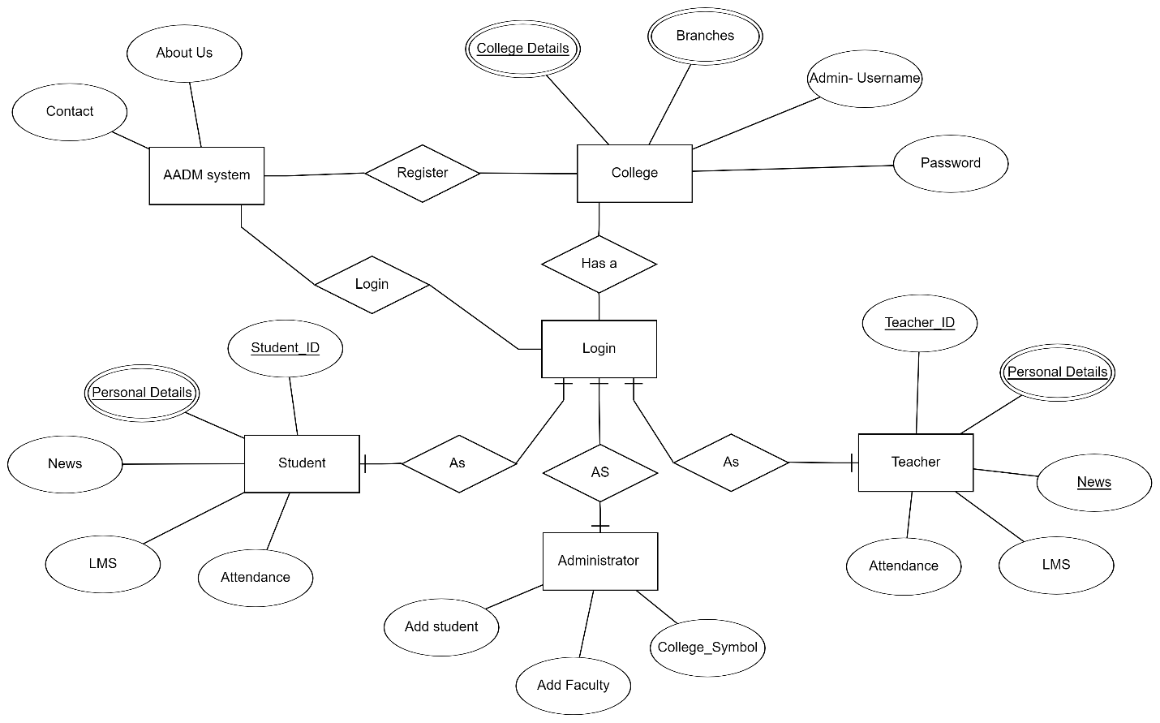

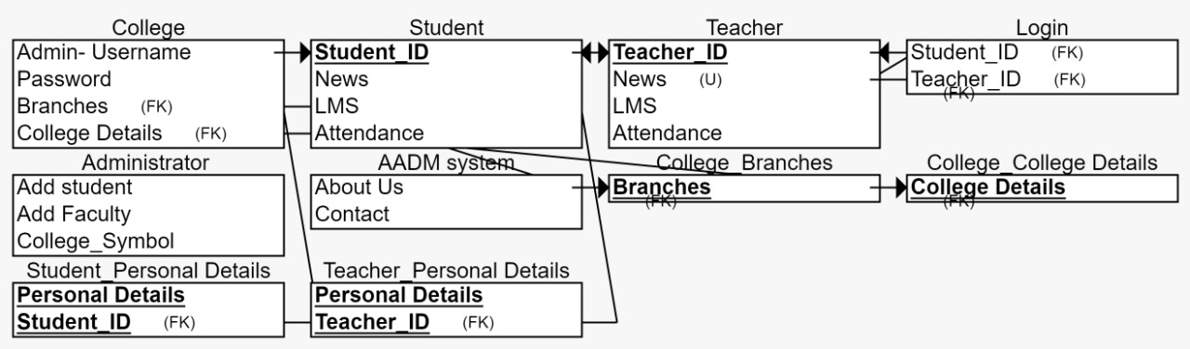

**4. GRAPHICAL USER INTERFACE (Screenshots of UI)**

**1. HOMEPAGE**

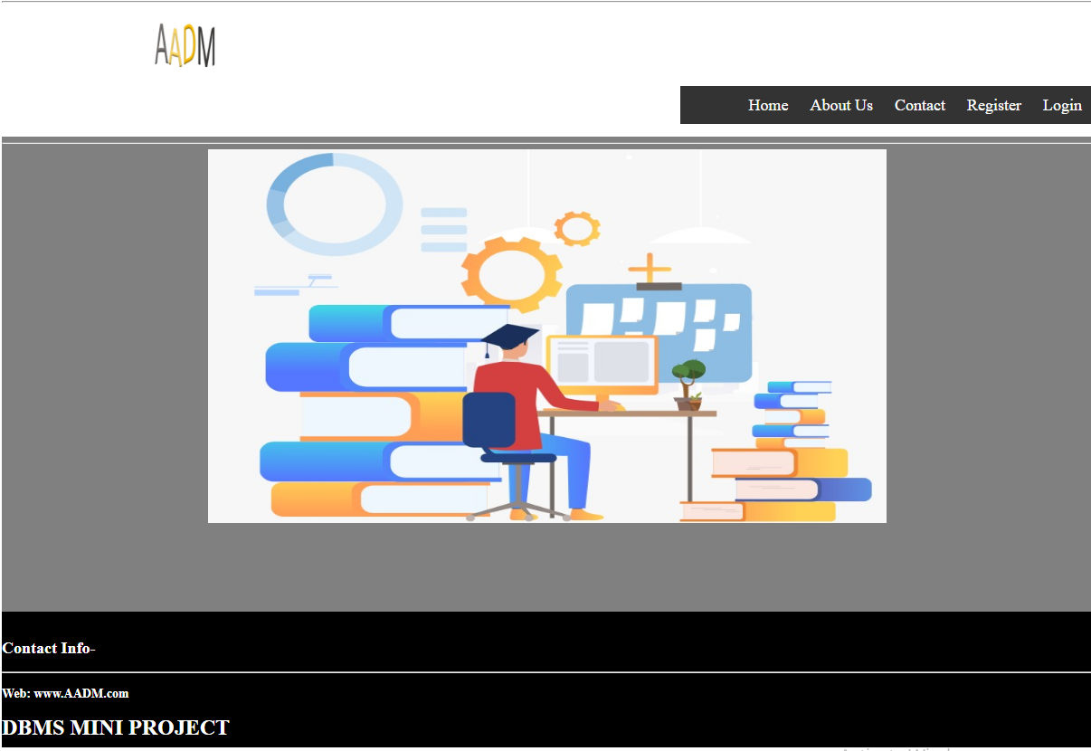

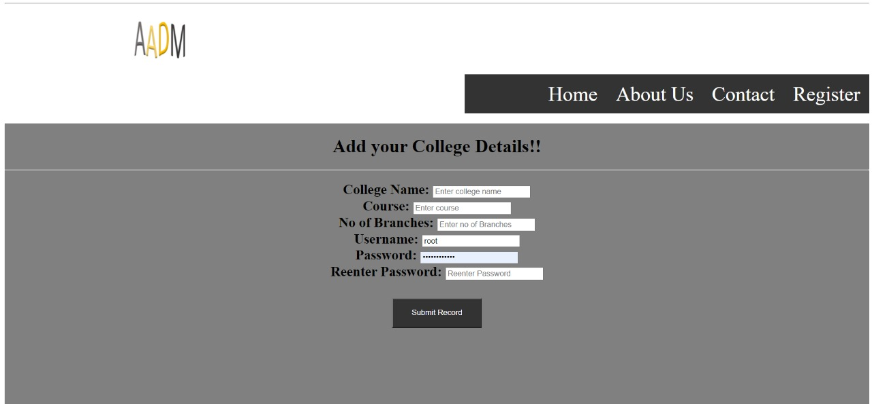**2. REGISTRATION PAGE**

**3. LOGIN AS COLLEGE PAGE**

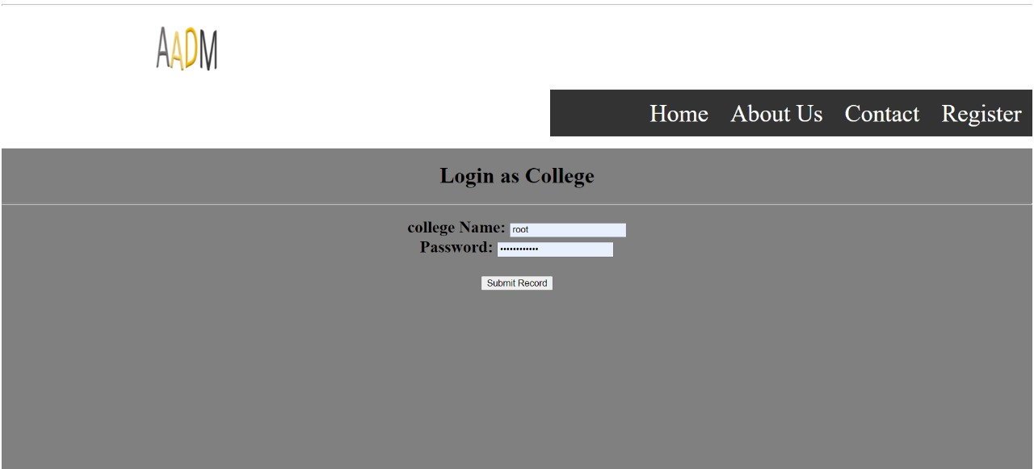

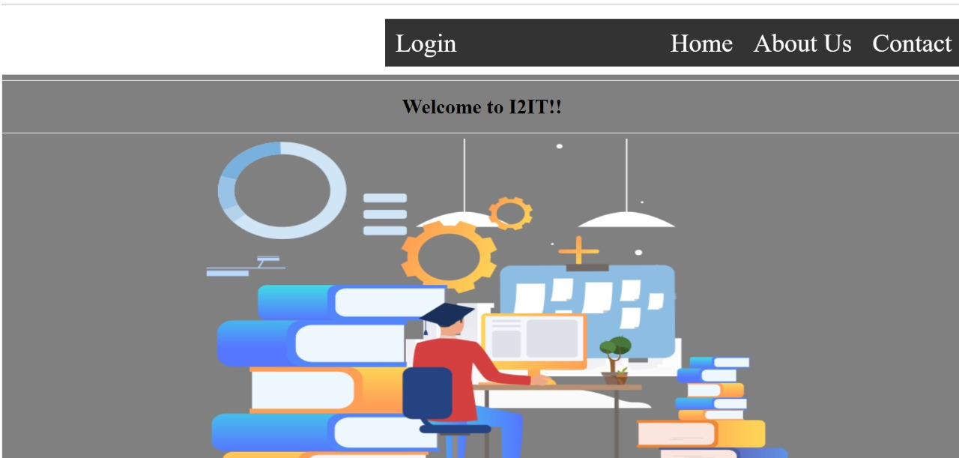**4. COLLEGE HOMEPAGE**

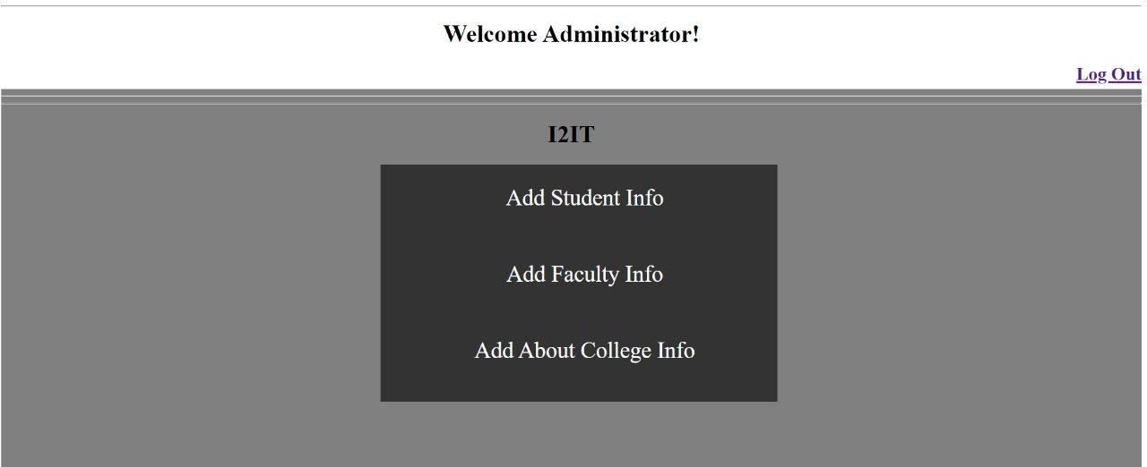**5. ADMINISTRATOR PAGE**

**6. STUDENT PAGE**

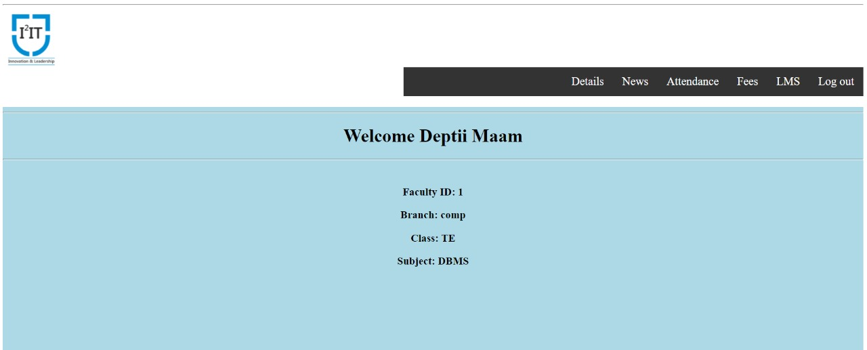

**7. FACULTY PAGE**

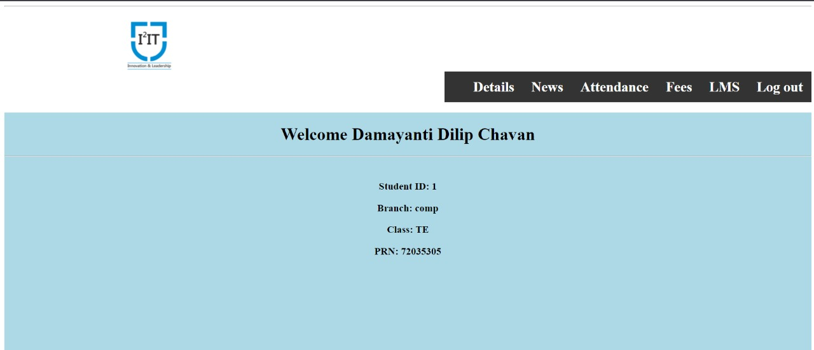

**5. CONCLUSION**

Our mini project is a college ERP system that handles colleges, students, and faculty details and provides different features like Attendance system, Fees Management, Display of News, Events, uploading Learning Resources in faculty view and Viewing it in student view. The program is very interactive and user friendly.

We found developing this mini project very interesting. It helped us to learn and implement various backend, frontend and database concepts. We enjoyed developing webpages using HTML and designing it using CSS. Then applying logic to organize the database and applying various concepts of DBMS made our concepts more clear. We also learned more about php. It was a great learning experience.

In future we are planning to add some more features like Library Management System, Attendance System, Fees Payment Platform and many more. We will make our website’s layout more interactive and presentable. We will make our code more readable and easily understandable to anyone.